

 Hello Solidity – Writing First Smart Contract

**Objective/Aim:**  
  
 . To learn the fundamentals of writing, compiling, and deploying a basic smart contract in Solidity using the Remix

Ethereum IDE

**Apparatus/Software Used:**

* Personal computer or laptop
* Internet browser (Chrome, Firefox, etc.)
* Remix Ethereum IDE (online platform)
* MetaMask wallet for transaction handling

**Theory/Concept:**

**Smart Contract – Definition**

A smart contract is a self-executing digital agreement stored on a blockchain. It runs according to its . programmed logic without the involvement of intermediaries.

**Main Characteristics of Smart Contract**

1: **Automation:** Executes automatically when specific conditions are satisfied

2: **No Intermediary Needed:** Operates on blockchain rules without a central authority.

3: **Immutable:** Cannot be modified once deployed.

4: **Transparency:** All code and transactions are publicly accessible for verification.

5: **Security:** Protected through cryptographic and blockchain consensus mechanisms.

**What is Solidity?**

Solidity is a high-level, object-oriented programming language used for developing smart contracts on the

Ethereum blockchain.

.

**Structure of a Solidity Smart Contract:**

1. **SPDX License Identifier** – Declares licensing information.
2. **Pragma Directive** – Specifies the compiler version.
3. **Contract Definition** – The actual smart contract logic.
4. **State Variables** – Data stored on the blockchain.
5. **Functions** – Define behavior and actions.



**Procedure:**

|  |  |  |  |
| --- | --- | --- | --- |
|  |  |  |  |
|  |  |  |  |
|  |  |  |  |
|  |  |  |  |
|  |  |  |  |
|  |  |  |  |
|  |  |  |  |

**Step 1: Open the Remix Ethereum IDE in your web browser**

**Step 2: Inside the contracts directory, create a new file, for example: SimpleStorage.sol.**

**Step 3: Write a basic Solidity program for a simple storage contract.**

**Step 4: Compile the contract using the Solidity compiler in Remix.**

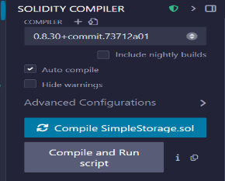

**Step 5: Choose Injected Provider as the environment for deployment**

**Step 6: Confirm the deployment transaction in MetaMask**

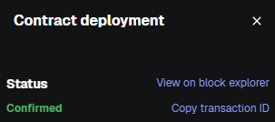

**Observation Table:**



After deploying, the contract was successfully compiled to bytecode and uploaded to the Ethereum blockchain via a transaction. The deployment resulted in a unique blockchain address for the contract, making it ready for execution

and interaction.